Mississippi Natural Heritage Program Web App for Environmental Review Requests

- To access the web app, go to https://www.mdwfp.com/museum/seek-study/heritage-program/

- Scroll down to the bottom of the page and click “Environmental Reviews”
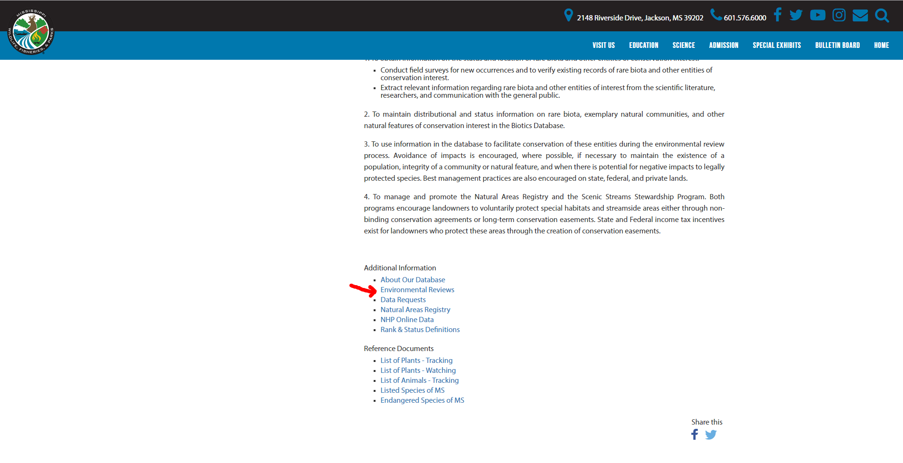

- Register as a new user
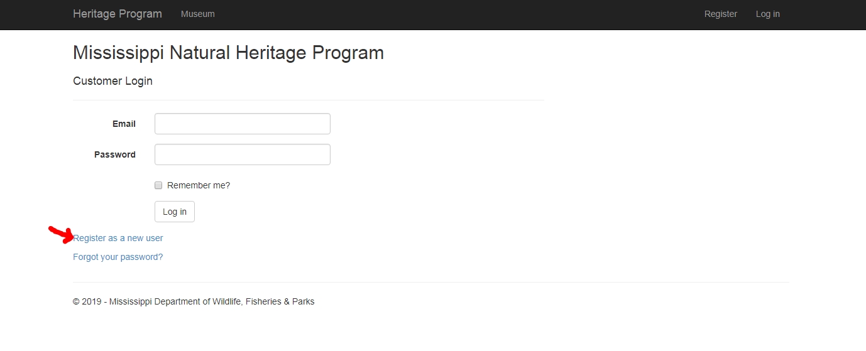

- Once you’ve completed registration, create your environmental review request by clicking “New”
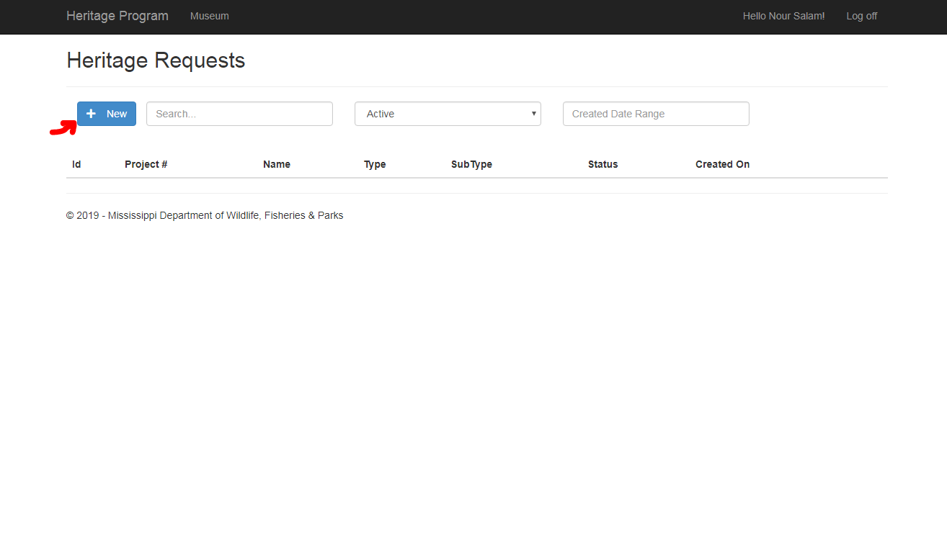

- Fill out the fields below as needed. File attachments can be uploaded to the request.
